**New Guest procedure March 2025**

**We are happy to share that we now have a new automated guest fee procedure which allows for an easier and quicker means of logging the attendance and paying for guests using the club.**

**Guest fees (updated to €6 to accommodate the new cost of the new functionality) will be taken automatically from your SmartClub lights purse upon booking confirmation. Please verify you have enough funds in your lights purse prior to making the booking.**

**Please follow the instructions below:**

1, Log in as usual to CM365 to book a court and select the timeslot required.

2, When the following pop up appears select “show guest options”

3, Select the number of guests you wish to invite, 1, 2 or 3. In the example below I selected 2 guests. If you wish to have opponents that are members also attend, select them from the opponents drop down. I selected two for my booking below.

**Please put the full names of the guests attending, this is the only record going forward for recording club guests, so recording the full name is very important** and press book.

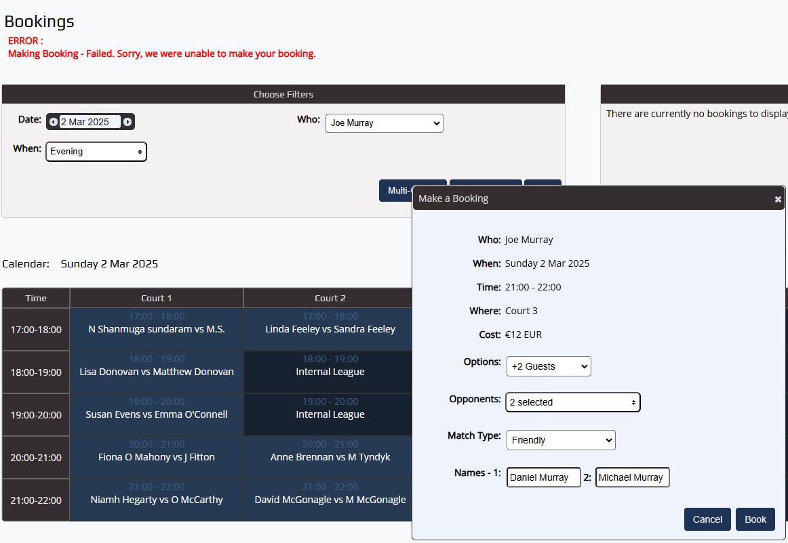

Please note the cost will appear as shown below, if you do not have sufficient funds in your lights purse to cover this cost the booking will fail with the following error.

