**The New Remote Light activation feature**

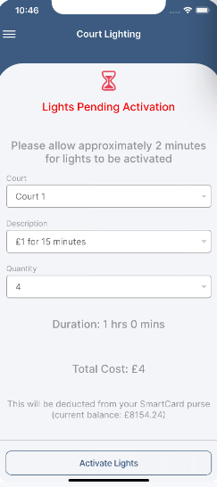

1, Choose  your Court

2, Choose the quantity, which is the number of Taps, same as tapping the card.

3, Click Activate lights.

The balance comes off your lights Purse balance on smartclubcloud.

You can interchange between card and app, so you can use whatever you feel like using.

**The New Contacts Feature**

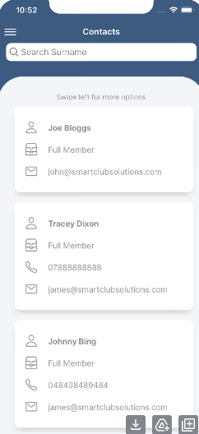

You can search other members in the club and request for them to give you permission to have them in your contacts. Once they approve their name appears in your contacts.

Once they are there you can email, call or text them from the app.

You can transfer funds over to your contacts and receive funds between your Lights Purse.

**Events, Finance and Profile.**

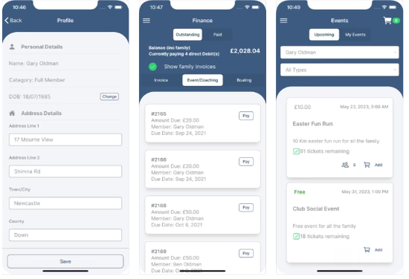

Everything else that a member usually does on [smartclubcloud.com](http://smartclubcloud.com/) can now be done on this APP.

Register for events e.g. club night, pay membership/coaching, top up your card. Change profile information etc etc.

You can also now book courts from the App.

**Virtual Smart Card.(Coming soon)** This does not work yet and will require some technology changes to the club house that smart club are still investigating.

This will basically remove your need to have a physical card, you can scan the QR code on the app to gain access to the clubhouse and tap for lights.

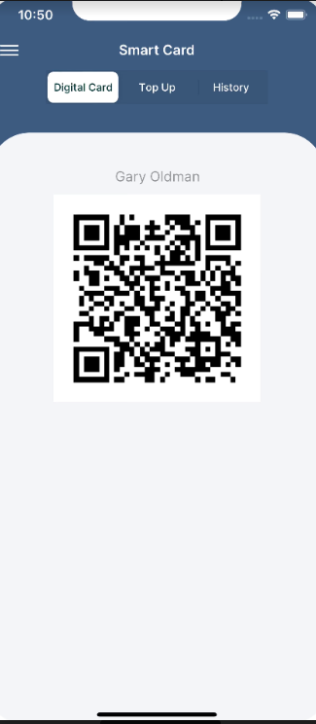

To Download, from your iPhone or Samsung go to their app stores and search from smart club solutions app. Download, log in with your smart club cloud login details and you are ready to go.

To download from Apple Appstore, scan this QR code with your phone or click the QR code

[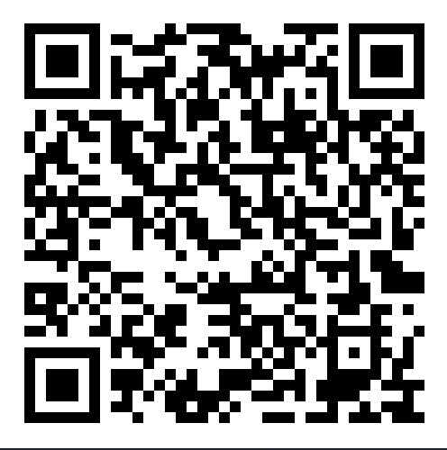](https://apps.apple.com/ie/app/smart-club-cloud/id6443400050)

To download for Android phones, please scan this QR code or click the QR code

[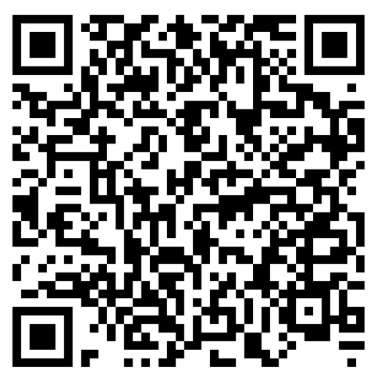](https://play.google.com/store/apps/details?id=com.smartclub.membercloud)